kond`Iya ivadyaalaya nambar 1 yaUinaT 9 BauvanaoSvar
KENDRIYA VIDYALAYA NO.1,UNIT IX, BHUBANESWAR
kxaa 5 ihndI iËyaaklaap pHa
AnaucCod kao pZ,kr p`SnaaoM ko ],,,,,,,,,,<ar ilaKao Á
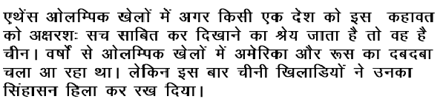
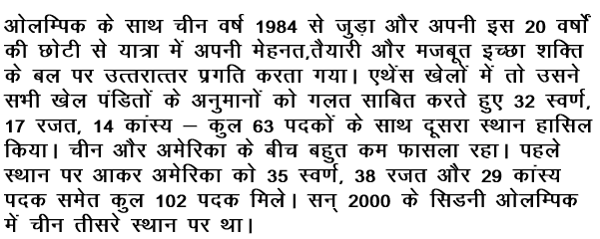

P`a0 Aaolaimpk ko saaqa caIna iksa vaYa- maoM jauD,a qaa Æ

]0

P`a0 2 Aaolaimpk KolaaoM maoM vaYaao-M sao ikna doSaaoM ka dbadbaa calaa Aa rha qaa Æ

]0

p`0 3 caIna nao kha^M ko Aaolaimpk KolaaoM maoM dUsara sqaana p`aPt ikyaa qaa Æ

]0

p`0 4 eqaoMsa Aaolaimpk KolaaoM maoM Amaoirka nao kula iktnao pdk jaIto qao Æ

]0

p` 0 5 isaDnaI Aaolaimpk KolaaoM maoM caIna nao kaOna saa sqaana p`aPt ikyaa qaa Æ
]0

AnaucCod kao pZ,kr naIcao ilaKo SabdaoM ko samaanaaqaI- Sabd ilaiKe

sa%ya saaonaa

caa^MdI pirEama

saf,r
saulaoK kIijae

kond`Iya ivadyaalaya nambar 1 yaUinaT 9 BauvanaoSvar
KENDRIYA VIDYALAYA NO.1,UNIT IX, BHUBANESWAR
kxaa 4 ihndI iËyaaklaap pHa
AnaucCod kao pZ,kr p`SnaaoM ko ],,,,,,,,,,<ar ilaKao Á

P`a0 Aaolaimpk ko saaqa caIna iksa vaYa- maoM jauD,a qaa Æ

]0

P`a0 2 Aaolaimpk KolaaoM maoM vaYaao-M sao ikna doSaaoM ka dbadbaa calaa Aa rha qaa Æ

]0

p`0 3 eqaoMsa ko Aaolaimpk KolaaoM maoM caIna nao kaOna saa sqaana p`aPt ikyaa qaa Æ

]0

p`0 4 eqaoMsa Aaolaimpk KolaaoM maoM caIna nao kula iktnao pdk jaIto qao Æ
]0

p` 0 5 eqaoMsa Aaolaimpk KolaaoM maoM Amaoirka nao kula iktnao pdk jaIto qao Æ
]0

AnaucCod kao pZ,kr naIcao ilaKo SabdaoM ko samaanaaqaI- Sabd ilaiKe

sa%ya saaonaa

caa^MdI pirEama

saf,r

saulaoK kIijae

kond`Iya ivadyaalaya nambar 1 yaUinaT 9 BauvanaoSvar
KENDRIYA VIDYALAYA NO.1,UNIT IX, BHUBANESWAR
kxaa 3 ihndI iËyaaklaap pHa
AnaucCod kao pZ,kr p`SnaaoM ko ],,,,,,,,,,<ar ilaKao Á
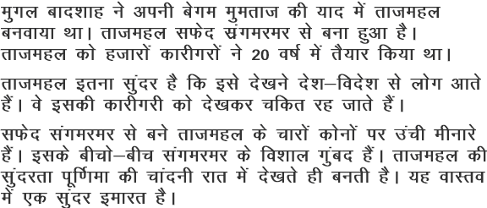

P`a0 maugala baadSaah nao tajamahla kao iksakI yaad maoM banavaayaa qaa Æ
]0

P`a0 2 tajamahla kao iksasao banaayaa gayaa hOÆ
]0

p`0 3 tajamahla kha^M banaa hOÆ
]0

p`0 4 tajamahla iktnao vaYa- maoM banakr tOyaar huAa qaaÆ
]0

p` 0 5 tajamahla ko caaraoM kaonaaoM pr @yaa banaa hOÆ
]0

naIcao ilaKo SabdaoM sao vaa@ya banaa[e

doSa

[maart

saundr

nadI

rat

saulaoK kIijae
Aaolaimpk KolaaoM maoM saMsaar ko saBaI doSaaoM ko iKlaaD,I ihssaa laoto hOM.AaOr
KolaaoM maoM pdk jaIt kr Apnao Apnao doSa kI Saana baZ,ato hOM.

